Week 6 - RMD creation

Aarti Ramani

January 18, 2023

# Markdown Basics

## Favorite Foods

1. Salads
2. Pizza
3. IceCream

## Images

Img: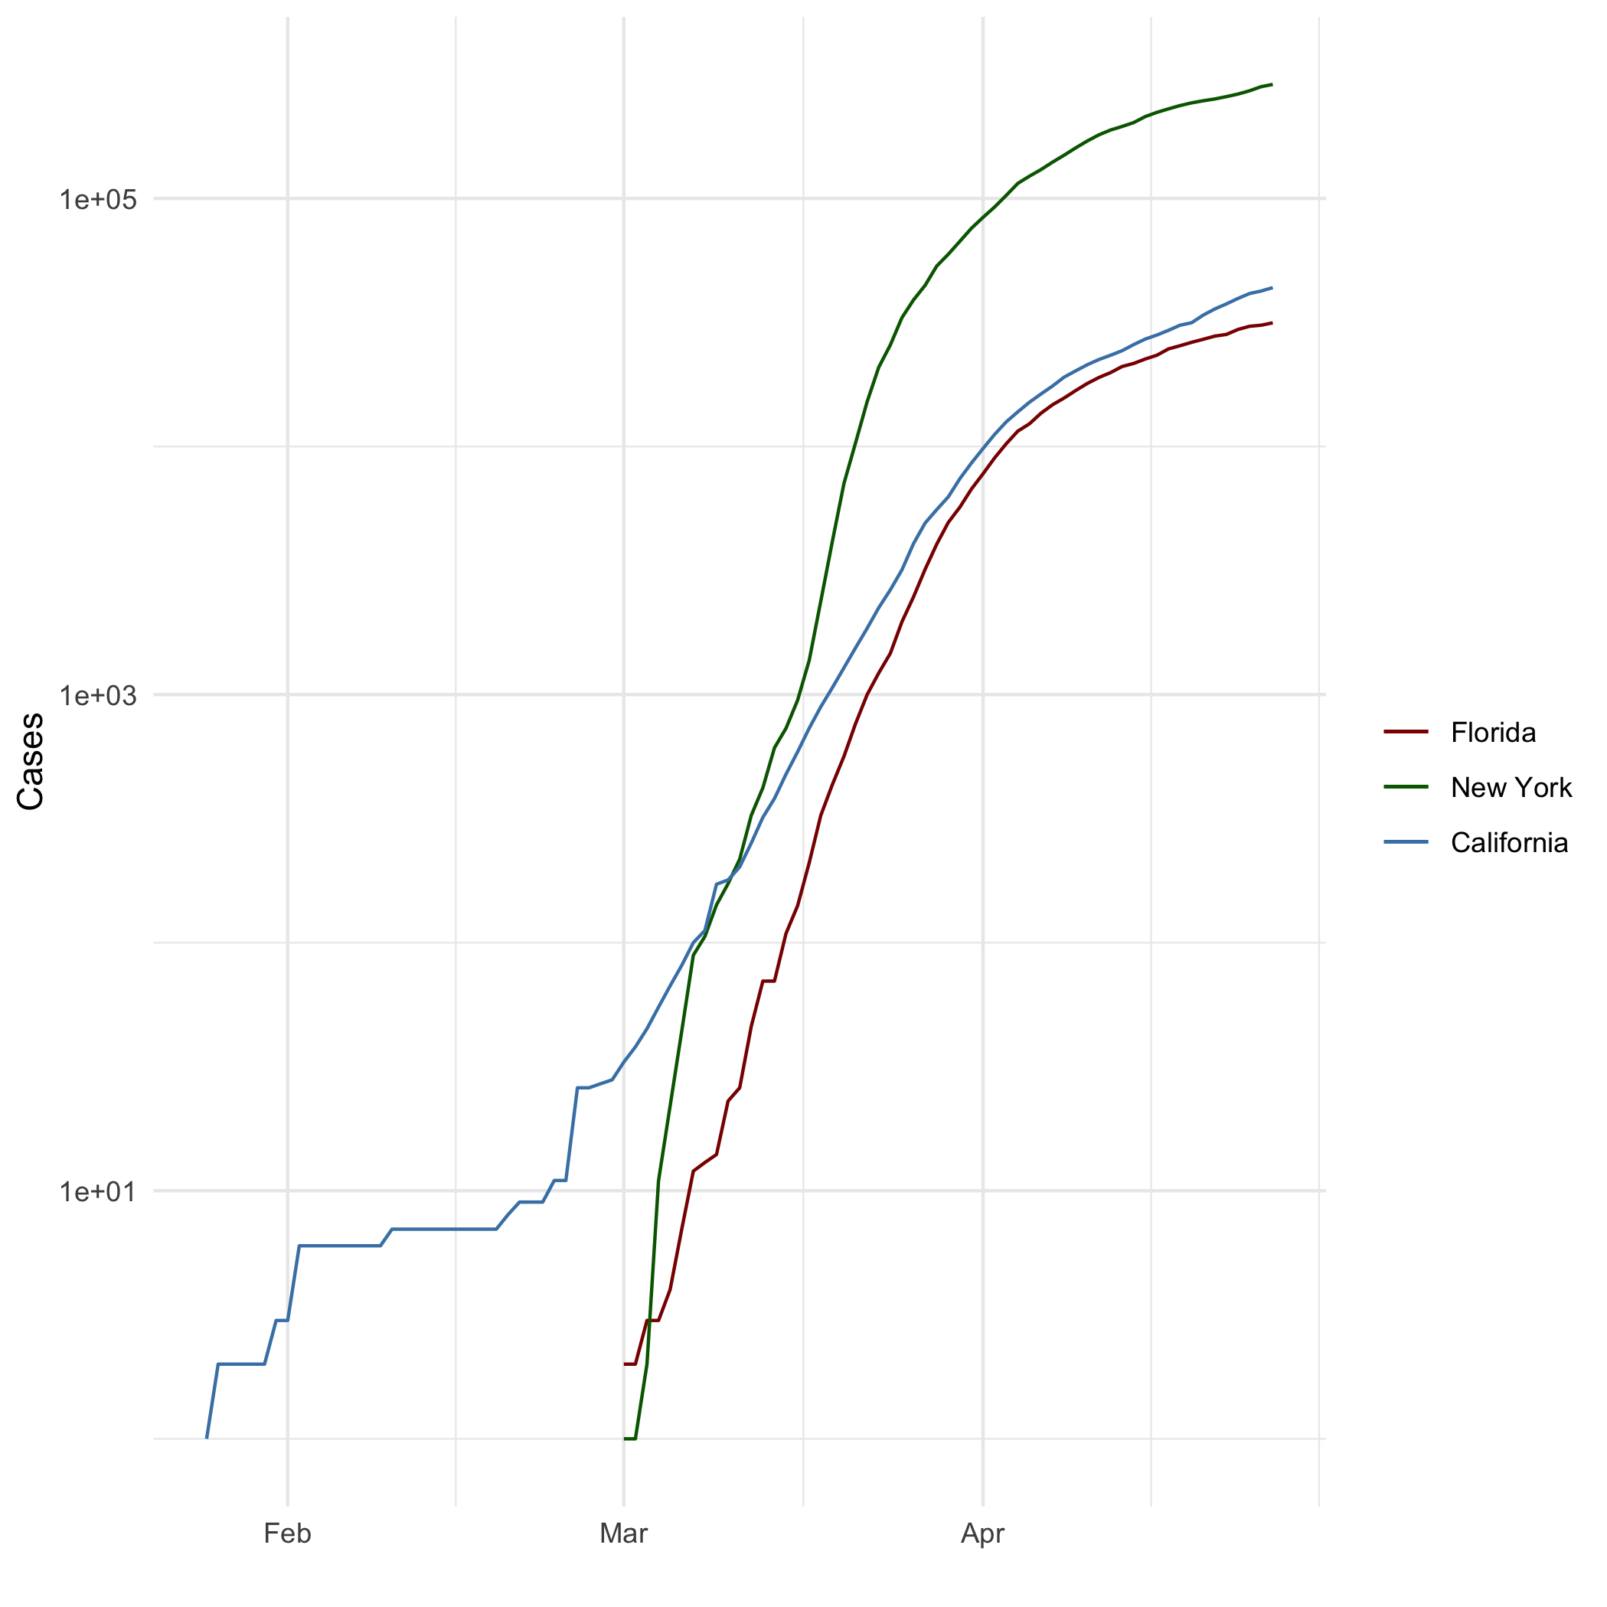

## Add a Quote

The journey of a thousand miles begins with one step.

Act as if what you do makes a difference. It does.

The way to get started is to quit talking and begin doing.

## Add an Equation

$${\left(a−b\right)}^{2}=a^{2}+b^{2}−2ab$$

## Add a Footnote

[1]

## Add Citations

* R for Everyone: Advanced Analytics and Graphics(Lander 2014)
* Discovering Statistics Using R(Field, Miles, and Field 2012)

# Inline Code

## Load the ggplot2 package  
library(ggplot2)  
theme_set(theme_minimal())   
# Load the `data/r4ds/heights.csv` to  
heights_df <- read.csv("C:/Masters/GitHub/Winter2022/Ramani-DSC520/data/r4ds/heights.csv")  
  
# https://www.rdocumentation.org/packages/ggplot2/versions/3.3.0/topics/geom_path  
# Load the file `"data/nytimes/covid-19-data/us-states.csv"` and  
# assign it to the `covid_df` dataframe  
  
covid_df <- read.csv("C:/Masters/GitHub/Winter2022/Ramani-DSC520/data/nytimes/covid-19-data/us-states.csv")  
  
# Parse the date column using `as.Date()``  
covid_df$date <- as.Date(covid_df$date)  
  
# Create three dataframes named `california_df`, `ny_df`, and `florida_df`  
# containing the data from California, New York, and Florida  
california_df <- covid_df[ which( covid_df$state == "California"), ]  
ny_df <- covid_df[ which( covid_df$state == "New York"), ]  
florida_df <- covid_df[ which( covid_df$state == "Florida"), ]

## NY Times COVID-19 Data

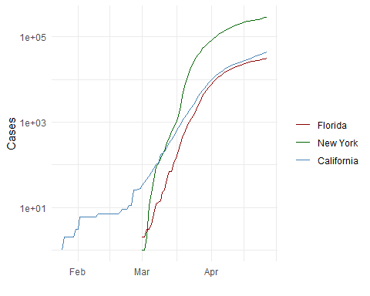

## R4DS Height vs Earnings

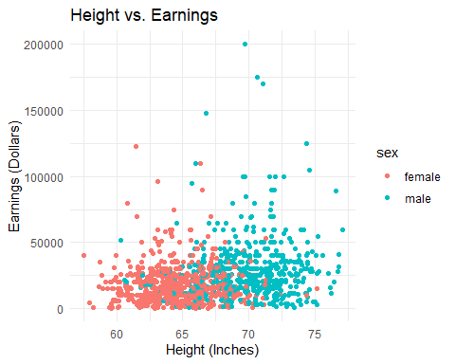

# Tables

## Knitr Table with Kable

library(knitr)  
knitr::kable(characters_df, caption='One Ring to Rule Them All')

One Ring to Rule Them All

| name | race | in_fellowship | ring_bearer | age |
| --- | --- | --- | --- | --- |
| Aragon | Men | TRUE | FALSE | 88 |
| Bilbo | Hobbit | FALSE | TRUE | 129 |
| Frodo | Hobbit | TRUE | TRUE | 51 |
| Galadriel | Elf | FALSE | FALSE | 7000 |
| Sam | Hobbit | TRUE | TRUE | 36 |
| Gandalf | Maia | TRUE | TRUE | 2019 |
| Legolas | Elf | TRUE | FALSE | 2931 |
| Sauron | Maia | FALSE | TRUE | 7052 |
| Gollum | Hobbit | FALSE | TRUE | 589 |

## Pandoc Grid Table

##   
##   
## +-----------+--------+----------------+-----------------+------+  
## | Name | Race | In Fellowship? | Is Ring Bearer? | Age |  
## +===========+========+================+=================+======+  
## | Aragon | Men | Yes | No | 88 |  
## +-----------+--------+----------------+-----------------+------+  
## | Bilbo | Hobbit | No | Yes | 129 |  
## +-----------+--------+----------------+-----------------+------+  
## | Frodo | Hobbit | Yes | Yes | 51 |  
## +-----------+--------+----------------+-----------------+------+  
## | Galadriel | Elf | No | No | 7000 |  
## +-----------+--------+----------------+-----------------+------+  
## | Sam | Hobbit | Yes | Yes | 36 |  
## +-----------+--------+----------------+-----------------+------+  
## | Gandalf | Maia | Yes | Yes | 2019 |  
## +-----------+--------+----------------+-----------------+------+  
## | Legolas | Elf | Yes | No | 2931 |  
## +-----------+--------+----------------+-----------------+------+  
## | Sauron | Maia | No | Yes | 7052 |  
## +-----------+--------+----------------+-----------------+------+  
## | Gollum | Hobbit | No | Yes | 589 |  
## +-----------+--------+----------------+-----------------+------+  
##   
## Table: One Ring to Rule Them All

# FootNote

[2]

# References

Field, A., J. Miles, and Z. Field. 2012. *Discovering Statistics Using r*. SAGE Publications. <https://books.google.com/books?id=wd2K2zC3swIC>.

Lander, J. P. 2014. *R for Everyone: Advanced Analytics and Graphics*. Addison-Wesley Data and Analytics Series. Addison-Wesley. <https://books.google.com/books?id=3eBVAgAAQBAJ>.

1. My first footnote
2. This is the end of assignment 4